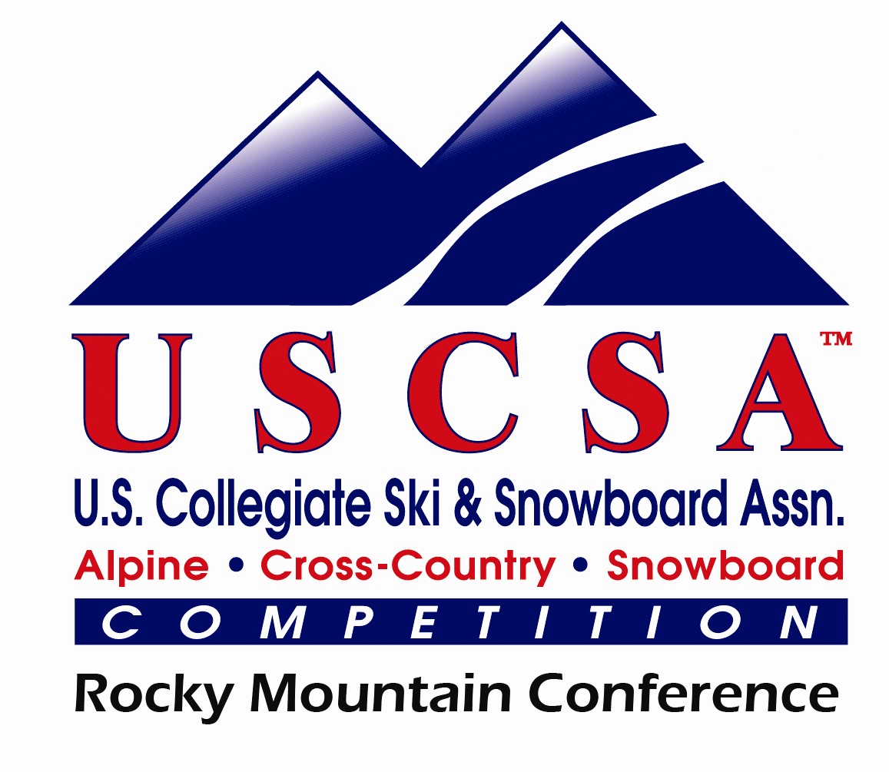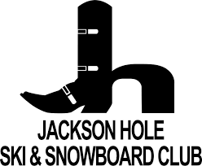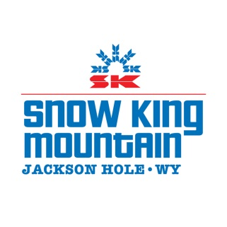

USCSA 2018 Western Regional Championship

EVENT DATES: February 22nd Training
February 23rd GS M/W Elk (2 lanes)
February 24th SL M/W Cougar
February 25th Dual SL M/W Cougar

Race Headquarters: Lodge Room at Snow King Center
Please respect the mountain’s facilities, keep it clean and store boots/bags out of the way.

Officals:
Technical Delegate: Mike Hammer
Race Administrator: Meta Zagar
Chief of Race: Branko Zagar

Entry Fee: - $225 per athlete participating in GS, SL and the Dual SL OR wishing to ski Sunday (includes lift tickets for Friday-Sunday)
- $190 per athlete participating in GS and SL ONLY (includes lift ticket for Friday-Saturday)
- $40 per athlete for Thursday training day
Notes – only 5 athletes per gender per team can race in the dual
SL. Individual qualifiers may also participate.
- All athletes and coaches may participate in the free cookout
Sunday
Please make checks payable to: Jackson Hole Ski and Snowboard Club
Check or Cash payment ONLY at Registration.

Coaches: 1 comp lift ticket per every 5 athletes on a team. All other coaches can purchase for $35 per day.
Volunteers: Email jmoyer@uscsa.com to gatekeep, handtime or slip course.

Registration:

Thu. February 22nd 8:30am – 12pm, 4pm - 7pm: Snow King Lodge – Lodge Room

Eligibility/ Seeding: All teams which have qualified through their conference are eligible to participate. Each team may bring 10 athletes per gender
One Scoring Team (5 athletes each) from each college plus their individuals are seeded by coaches. Only the first 5 seeded athletes count for the team’s result

Entry Procedure:
Each Team Captain must submit one USSA Team Entry Form per gender.
Only one team per college is seeded according to coach’s discretion.

Entry Deadline: WEDNESDAY, February 21st by 3pm ($50 late fee per team).
Submit Entries to: Meta Zagar racesecretary@jhskiclub.org

Liability Release:
*All athletes must have signed liability release: http://www.jhskiclub.org/athlete-raceevent-waiver No racer will start without a Release.

Team Captains Meetings:

Thu. February 22nd – 7pm: Snow King Lodge – Lodge Room

Fri. February 23rd – 5pm: Snow King Lodge – Lodge Room

Sat. February 24th– 5pm: Snow King Lodge – Lodge Room

Rules:
All USCSA rules will be in effect.
NO lift line cutting.
NO fast skiing on public trails.

Protest/Awards: $20 in cash. MUST file protest within 15 minutes of posted DQ list. Awards will include individual medals for 1st, 2nd, & 3rd place athletes for each day. Top 3 team awards will be given to each gender for the overall competition result. Eligibility for advancement to USCSA Nationals will be based only on the GS and SL results.
**All awards on Sunday**

LODGING: Snow King Hotel will have a $79 rate per night per room. https://reservations.travelclick.com/77244?&amp;rateplanID=2493751#/guestsandrooms Corporate code: JHSC

QUESTIONS / RACE CONTACT:
Nicholas LaBue
Director/Head Coach
USCSA Ski Team at Colorado School of Mines
USCSA Rocky Mt. Conference Coordinator
Phone: (203) 206-1577
nlabue39@gmail.com

